1. Lambda Expression:
   1. The most exciting feature in Java8.
   2. The reason is it allows us to write less code and helps us to achieve more.
2. 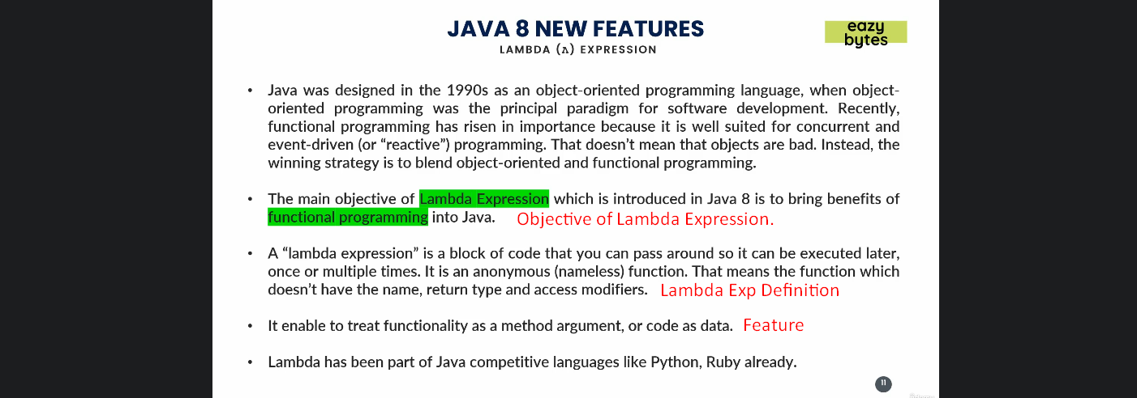
3. With Lambda Expression, you can pass business logic around like you used to pass parameters.
4. You can reduce the # of lines of codes.
5. Using Lambda Expression, we can pass code as value.